Insert Company Logo

Insert Date
Insert Committee Chair Name
Insert Address

Landscape Industry Opposition to Gasoline Powered Landscape Equipment Bans

Dear Chair Name
Landscape companies throughout (insert state or locality) specialize in lawn care, landscape maintenance, tree care, irrigation and water management. Landscape professionals work daily preforming essential services to homes and businesses to maintain their landscapes, sustain the environment and enhance and maintain healthy and safe green spaces.
We share (Insert State or Locality) policymakers’ intent to reduce carbon emissions from gas-powered landscape equipment as quickly as possible. Still, we must do so in a responsible manner that mitigates the negative financial impact on the landscape industry.
Landscape professionals work every day to take care of (insert state or locality) green spaces. The landscape industry cares deeply about the environment, and we do support a responsible transition to zero-emission equipment (ZEE). We appreciate the approach offered to prioritize funding and incentive over many years to support the transition. Unfortunately, we cannot support legislation that puts in place an arbitrary timeline of 2030 because we just do not know when all ZEE will be viable for the landscape industry. The reality is that the commercial-grade ZEE currently on the market has significant performance issues and cost issues and we would like to take this opportunity to provide the perspective of the landscape industry, the hurdles associated with the transition and also offer support for proper funding.
Performance
Equipment performance and run-time are common concerns for landscape professionals and present technological challenges that must be overcome for widespread use of zero emission landscape equipment. Unlike a homeowner that uses an zero emission equipment for less than an hour, maybe in a given week, the landscape industry is operating commercially using this equipment daily, under rigorous conditions and during long durations. Also, many landscape professionals operate on commercial properties like corporate campuses, parks, resorts and other large green spaces which demand stronger performance and power capabilities. Unfortunately, the available zero emission equipment is not capable of this sort of use pattern currently.
NALP also conducted a survey to poll professional landscape companies nationally. Both performance and cost remain tremendous hurdles, specifically for the larger commercial equipment that requires significantly more run time and power. From a performance perspective the industry continues to hear from landscape professionals about ZEE landscape equipment:
- The power is just not comparable yet
- Impossible to use exclusively on large scale commercial jobs like HOAs, resorts, business parks and other public and commercial green spaces
- Requires too many batteries to conduct their job function in an efficient manner
- Charging issues in the field and in the workshop
- Durability concerns
- Batteries are too heavy
- Cannot mow slopes on riding mowers because of the weight issue
- Mow times are longer and batteries cannot last a full work day
- Leaf removal during seasonal changes is very difficult
- Debris removal to mitigate fire spread is significantly more difficult
- Lack of dealers and maintenance shops to support transition
- Batteries are not interchangeable between brands
Additionally, some specific concerns from landscape professionals that participated in the survey include:
“Product availability. While many products are available and the technology is advancing, commercial use electrical hand-held equipment is still limited and presents challenges. Product reliability, charging station access, and maintenance operations are just a few challenges that I feel are at the forefront of the issue.”

“Durability of the machines, the batteries are so heavy the frame has to be light. Mowing slopes, they are so heavy they don’t hold hills. Lack of repair expertise loyalty. Parts are difficult to acquire and take a long time to get. Battery life in heavy cutting conditions and longer mow times due to double cutting.”

“Blower power and battery life especially during leaf removal. Building out branch charging infrastructure is also a challenge as it is costly and often requires rewiring the whole building to supply enough power to recharge a whole branch.”
This is some of the most compelling evidence NALP can provide in support of our position and echoes the sentiment of what we hear from our members on this issue daily throughout the Nation.
NALP also acknowledges that in some instances companies have been able to successfully transition, detailed in NALP survey results. BUT those companies are significantly in the minority and operate in very affluent and wealthy areas. We highlight this fact because our understanding is that the cost increase for using only ZEE is approximately a 30%-40% increase over average industry pricing for the customer. This point is critically important as this proposed rule will further disadvantage small and minority owned businesses, but ALSO those lower income communities they service that deserve properly maintained healthy green spaces at affordable prices.
To further support the performance deficiencies is data from a report provided by a major equipment manufacturer that produces ZEE and non-ZEE SORE.
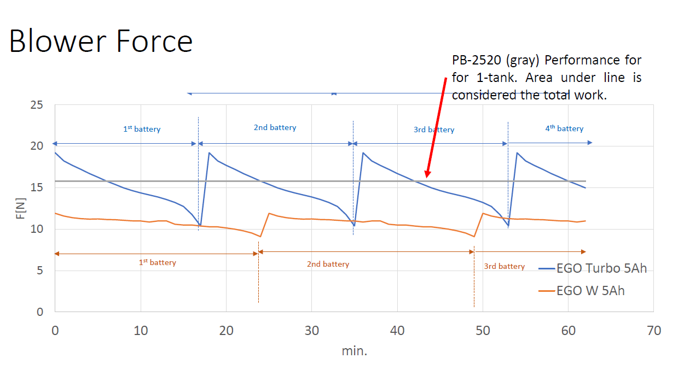
The graph clearly shows that a ZEE blower is not comparable at this time. The performance of the ZEE immediately begins to decline the moment it begins until the battery dies only 18 minutes later, while the gas-powered blower maintains a strong performance the entire hour and without unnecessary downtime to change batteries.
Cost
The entire cost for transitioning away from gas powered landscape equipment must be completely understood and realized. First, there is the immediate cost of purchasing the actual equipment, which by itself is not that different. Where the price starts to jump is when you factor in the cost of batteries, the cost to change and retrofit your shop and how you handle inferior products in the midst of a labor crisis.
In examining the cost, the first thing to consider is the actual equipment. For example, commercial-grade handheld electronic leaf blowers have significant cost concerns for the landscape industry. One popular manufacturer’s electric leaf blower retails for approximately $350 - $400, similar to the same manufacturer’s gas-powered unit. However, to use this electric leaf blower for an entire workday requires the purchase of extra batteries and chargers thus, driving the up-front cost to exceed $3,000. More alarming is when you look at larger equipment. Popular commercial gas-powered riding mowers range from $8,000-$11,000 while the few commercial riding ZEE mowers available with 4-5hr run time range from $16,000 to 21,000+. These are significant up-front investments for landscapers, the majority of whom are sole-proprietor (single employee) businesses, with no guarantee they will recover the difference based on energy costs and maintenance.
Now let’s talk batteries. Batteries remain a significant barrier for the transition to occur based on cost, amount needed, how they’re charged and how they’re disposed. Run time for the batteries varies by equipment. For a rider mower the run time for a battery is somewhere between 4 and 6 hours, while for handheld equipment that run time is somewhere between 10 and 30 minutes per battery. With this data we examined what a typical three-person landscape crew may require from a battery standpoint.
 | Active Use Time of Equipment per lawn | X 20 Lawns | # of Batteries Needed
Rider Mower | 20 Minutes | 6 hours, 40 minutes | internal
String Trimmer | 10 Minutes | 3 hours, 20 minutes | 14 batteries
Edger | 5 Minutes | 1 hour, 40 minutes | 10 batteries
Blower | 5 Minutes | 1 hour, 40 minutes. | 10 batteries

Looking at this data it would take an average crew 34 batteries in ONE day to complete a typical day; while the rider mower would not have enough charge to complete all 20 lawns. The rider mower is an important piece of landscape equipment that currently has the largest cost and efficiency hurdles between gas and ZEE models. Switching batteries this frequently reduces productivity and efficiency for the landscape crew. The costs associated with those batteries:

Battery Cost | Charger Cost | Total
$179  -price based on retail price at Home Depot from a leading manufacturer | $50  -price based on retail price at Home Depot from a leading manufacturer | $229 x 34 = $7,786  just for this one crew which also excludes the riding mower battery

Considering that the batteries will need to be replaced every 300-500 charge cycles which would mean that they would likely need to be replaced at least once during the product’s life cycle we can estimate a total for this three-man crew to be (2 x $7,786) = $15,572. The costs associated with these batteries is significant and charging each battery for approximately 8 hours will add an additional $5 to $6 daily in energy costs associated for charging each battery prior to each day the battery is used.
Compatibility is also an issue for batteries. Battery technology for ZEE is proprietary information and therefore the batteries are not compatible between different manufacturers. This presents a problem because it would require landscape companies to move to a single manufacturer approach rather than using different equipment from different manufactures. This could lead to companies being locked into one manufacturer, reduce competition, and strengthening manufacturer influence over the company based on their specific needs.
The infrastructure on both the micro and the macro level is not currently in place to fully support this transition. On the micro level landscape companies will need to fully retrofit their shops to support the amount of voltage that will need to be used each day to safely charge all of the ZEE. Vehicles used to transport crews and equipment will also need to be redesigned to support charging stations to ensure complete operational capabilities once out in the field, this will raise the overall “cost” factor detailed above significantly. From a macro level there is currently not enough electric equipment in the stream of commerce due to supply chain issues and even if the equipment were available the dealerships that play a critical role in assisting in maintaining this equipment is not yet in place.
The last issue with cost that we want to address is labor. ZEE lack the same performance capabilities detailed above and require frequent battery changes both of which reduce the productivity and efficiency of a landscape crew in the field. This reduction in productivity puts landscape companies in a tough spot since they are already faced with a historic work force crisis. This is tough on an industry that cannot find enough willing and capable employees to now rely on less efficient equipment that takes more time and requires additional labor to perform the same task in the same amount of time to remain competitive and profitable.
All of this considered together (equipment cost, battery cost, increased labor) represents significant cost impediments to make a complete transition to ZEE.

Funding & Education
NALP appreciates the efforts to provide a tax credit to incentivize this transition. We also suggest that tax credits be offered not only for the purchase of ZEE SORE but also for batteries. We also believe tax credits should be available for investments made by business owners to retrofit their shops and vehicles to enable the capability to charge their equipment. We also believe there should be funding for education on how to use and maintain the equipment.
In Conclusion
NALP shares the objective a responsible transition to ZEE SORE, but we want to be clear that current ZEE is not quite ready for complete adoption by the landscape industry and we need to ensure proper funding is provided. We look forward to working with this committee and other policy makers on this very important issue.
Sincerely
Insert Name
Title
Company

GrePro Blog “The Charging Cycles of Lithium-Ion Polymer Batteries” March 25, 2020 https://www.grepow.com/blog/charging-cycles-of-lithium-ion-polymer-batteries/

