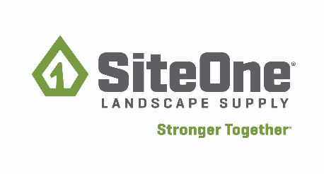
Safety Competition Study Guide

Table of Contents
- Introduction
- Safety Requirements
- Safety Competition
  - Assumptions
  - Rules
- Study Guide
  - OSHA General Duty Clause Regulation
    - General Duty Clause Explained
    - OSHA Regulation Excerpt
  - DOT Commercial Motor Vehicle Safety
    - Safety Topics-Wheel Chocks and Safety Cones
    - Vehicle Inspection- DVIR
    - Transporting Hazardous Material
  - OSHA Hazardous Communication Regulation
    - Safety Data Sheets
    - Safety Topics- Solvents, Hazcomm Labels,
    - NIOSH Pocket Guide
  - Hazard Recognition
    - Safety Topic’s-Hazard Awareness, Hazard Recognition, Hazard ID
  - PPE-Personal Protective Equipment
    - PPE Requirements
    - Glove Safety
  - Chemical Spill Reporting
    - Chemical Spill Response
    - Reporting and Investigating
  - Ergonomic
    - Safe Lifting, Push Vs. Pull
    - Sprains/Strains Safety Topic
    - Watch your Step Slip, Trip and Falls
  - Fall Protection
    - Why is Fall Protection Important
  - Ladder Safety
    - Ladders OSHA 1910.223
    - Ladder Safety Topics
    - Hazmat Spill
  - OSHA Powered Industrial Truck (PIT) Regulations
Note: Students will not be operating a forklift during exercise
    - General Forklift Operation and Training
    - General Operating Forklifts
    - General PIT Daily Checklist

